Remove the Old Exchange Account
Open the Gmail app.
Tap the menu (three bars) icon in the upper left corner
Select Settings
Select your current account (yourname@jfscinti.org or yourname@jfedcin.org or yourname@mayersonjcc.org)
Tap the menu (three dots) icon in the upper right corner
Select manage accounts
Select your current Exchange account (yourname@jfscinti.org or yourname@jfedcin.org or yourname@mayersonjcc.org)
Select Remove Account
Select Remove Account (to confirm)

Setting Up a NEW Office 365 / Microsoft 365 Email on an Android Device
Open the Gmail app.
Tap the menu (three bars) icon in the upper left corner
Select Settings
Select Add account
Select Exchange and Microsoft 365
Enter your full email address (yourname@jfscinti.org or yourname@jfedcin.org or yourname@mayersonjcc.org) and select Next
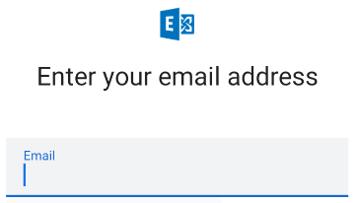
(If you are asked if this is Work/School account or Personal, Select Work/School).
Enter your password and select Sign In. (This is the password you created when you signed on to Office 365).
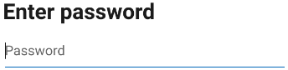

Accept – Connection our server

Save – Settings

You may need to Review Permissions to allow Gmail acces
Select Activate to enable device admin privileges
Select Allow to let Gmail access contacts
Select Allow to let Gmail
Select Done

